| **Test Name** | | | BCCCP Test | | | |
| --- | --- | --- | --- | --- | --- | --- |
| **Use Case Tested:** | | | Car Enter, Issue Adhoc Ticket, Pay for ticket, Car Exit | | | |
| **Test Description:** | | | This test script serves the purpose of testing proper functioning of the steps described in the chosen use case scenarios. | | | |
| **Pre-conditions** | | | In order to execute the steps in this test script knowledge over the system and representative data needs to be acquired | | | |
| **Post-conditions** | | | Successfully testing the possibilities in the system, verifying expected results or finding new problems | | | |
| **Notes:** | |  | | | | |
| **Result (Pass/Fail/Warning/Incomplete)** | |  | | | | |
|  | **TEST STEP** | | | **EXPECTED TEST RESULTS** | P | F |
|  | Click the red “No car detected” button in “Entry Outside Sensor” | | | The button change to a green button saying “Car detected” | X |  |
|  | Click “Issue Adhoc Ticket” | | | System displays ticket information in the “Entry ticket printer” area below | X |  |
|  | Press “Take ticket” in the EntryPillarUI | | | Red button “Gate down” will become green button “Gate up” | X |  |
|  | Enter the Barcode details of the ticket onto the PayStationUI and click “Read Ticket” | | | System will show how much to pay | X |  |
|  | Click “Pay” | | | System will show the details in the “Paystation ticket printer” are below | X |  |
|  | Press “Take ticket” | | | System will return to the default layout | X |  |
|  | Enter invalid data (not the right barcode ticket) | | | System will reject the ticket | X |  |
|  | Press the button in Entry Inside Sensor | | | “Car detected”  and status will change to “Entering” | X |  |
|  | Click the red “No car detected” button in “Entry Outside Sensor” | | | Status will change to “Entered” | X |  |
|  | Click the red “No car detected” button in “Exit Inside Sensor” | | | The button change to a green button saying “Car detected” | X |  |
|  | Enter the ticket barcode given before in the ExitPillarUI and click “Read ticket” | | | System will process the ticket and ask to take the ticket if it is correct | X |  |
|  | Enter trash data (incorrect ticket barcode) | | | System will reject the ticket | X |  |
|  | Press “Take ticket” in the ExitPillarUI | | | System will show “Ticket taken” and the gate will open | X |  |
|  | Click the red “No car detected” button in “Exit Outside Sensor” | | | The button change to a green button saying “Car detected” | X |  |
|  | Click the red “No car detected” button in “Exit Inside Sensor” | | | Status will change to “Exited” | X |  |

|  |  |  |  |  |  |
| --- | --- | --- | --- | --- | --- |
| **Test Data Table** | | | | | |
|  | **1** | **2** | **3** | **4** | **5** |
| Ticket barcode: A3 |  |  |  |  |  |
| Trash data: asd |  |  |  |  |  |

# Screenshots:

# Test step 1:

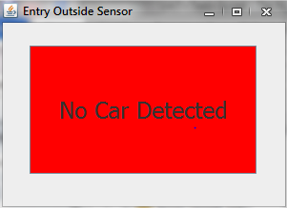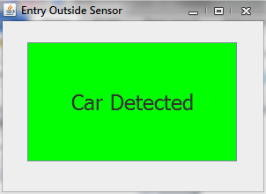

# Test step 2:

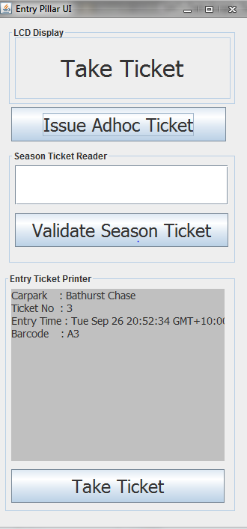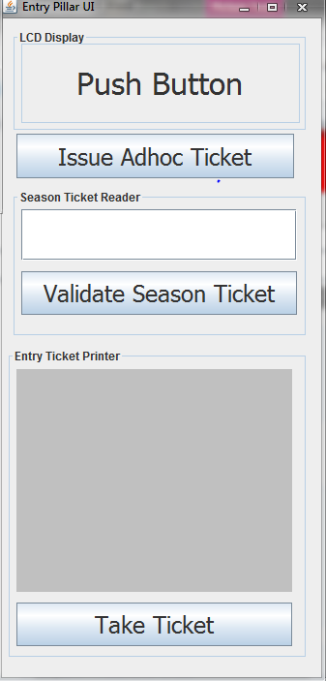

# Test step 3:

# 

# Test step 4:

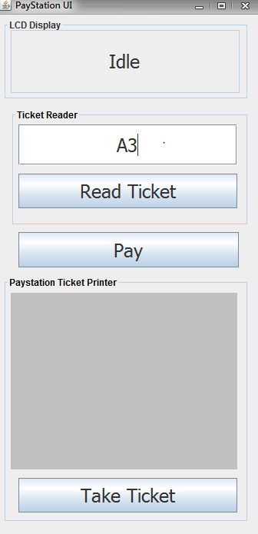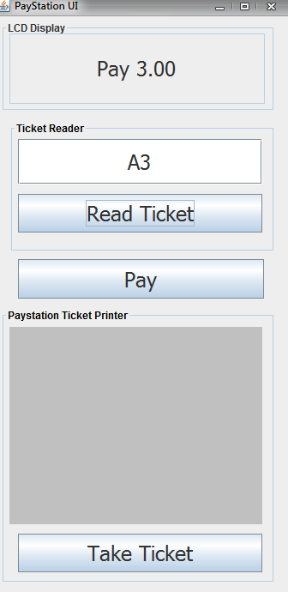

# Test step 5:

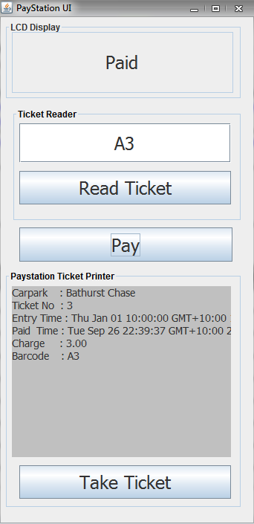

# Test step 6:

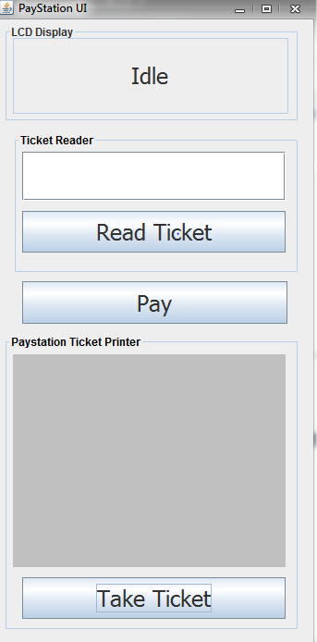

# Test step: 7

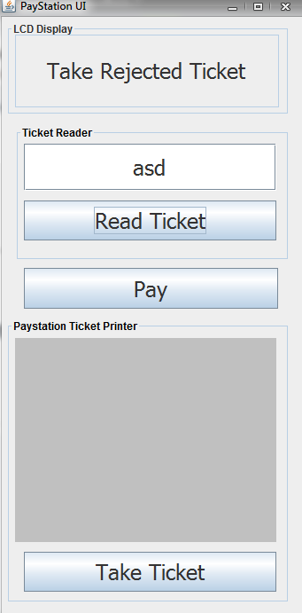

# Test step 8:

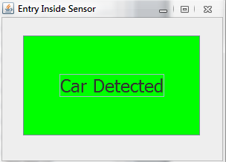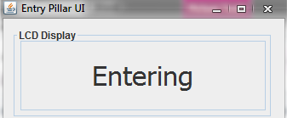

# Test step 9:

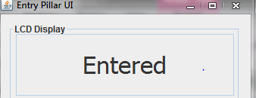

# Test Step 10:

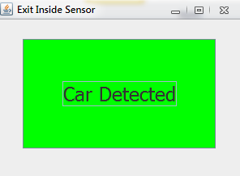

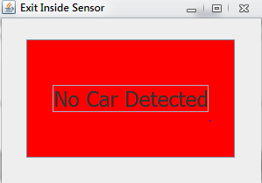

# Test Step 11:

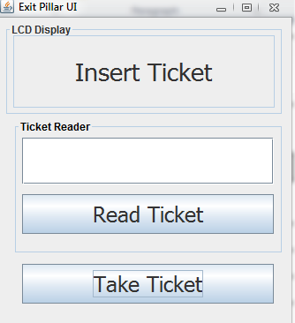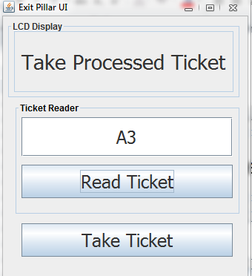

# Test Step 12:

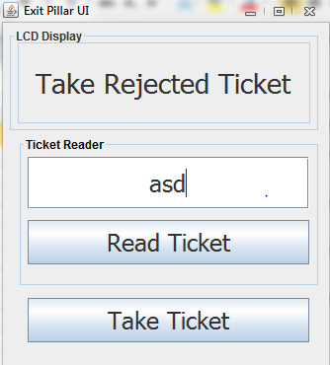

# Test Step 13:

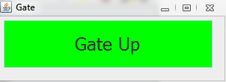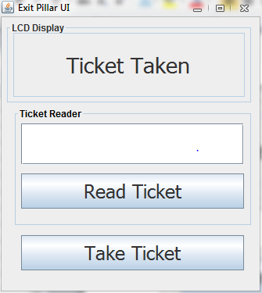

# Test Step 14:

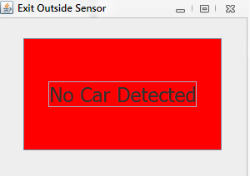

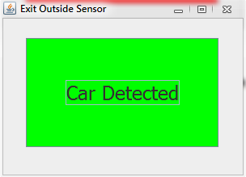

# Test Step 15:

